**Report**

|  |  |
| --- | --- |
| Date | 30 July 2025 |
| ID | SWUID20250188226 |
| Project Name | Global Food Production Trends and Analysis (1961–2023) |
| Maximum Marks | 5 Marks |

A report is a comprehensive document that provides a detailed and structured account of data analysis, findings, and insights. It is typically used for in-depth analysis, documentation, and communication of results. Reports are suitable for a diverse audience, including decision-makers, analysts, and stakeholders who need a comprehensive understanding of the data.

Designing a report in Power BI involves connecting to data sources, creating visualizations like charts and graphs, customizing their appearance and interactivity, organizing them logically on the canvas, formatting elements for consistency and clarity, and optionally creating dashboards for a summarized view. Throughout the process, it's essential to consider the audience's needs and ensure the report effectively communicates insights from the data. Finally, iterate based on feedback to continually improve the report's design and usefulness.

# Power BI Report View

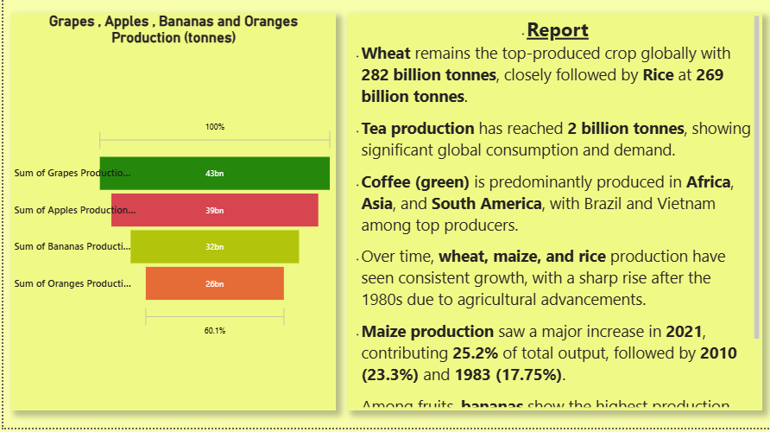

# Key Observations from Report

• Wheat remains the top-produced crop globally with 282 billion tonnes, closely followed by Rice at 269 billion tonnes.

• Tea production has reached 2 billion tonnes, showing significant global consumption and demand.

• Coffee (green) is predominantly produced in Africa, Asia, and South America, with Brazil and Vietnam among top producers.

• Over time, wheat, maize, and rice production have seen consistent growth, with a sharp rise after the 1980s due to agricultural advancements.

• Maize production saw a major increase in 2021, contributing 25.2% of total output, followed by 2010 (23.3%) and 1983 (17.75%).

• Among fruits, bananas show the highest production, followed by apples, grapes, and oranges, highlighting demand for these commodities.